**Experiment 2.3**

**Student Name: Sahul Kumar Parida UID: 20BCS4919**

**Branch: CSE Section/Group: WM904/B**

**Semester: 5th Date of Performance: 20/10/22**

**Subject Name: Machine Learning Lab Subject Code: CSP-317**

**1. Aim/Overview of the practical:**

To implement k-nearest neighbors (KNN) algorithm.

# 2. Task to be done:

i) Create feature and target variables.

ii) Split data into training and test data.

iii) Generate a k-NN model using neighbours value.

iv) Train or fit the data into the model.

v) Predict the future.

# 3. Apparatus/Simulator used:

* Jupyter Notebook/Google Collab
* The k-nearest neighbor algorithm is imported from the scikit-learn package.
* Seaborn is a Python data visualization library based on matplotlib.

**4. Code and Output:**

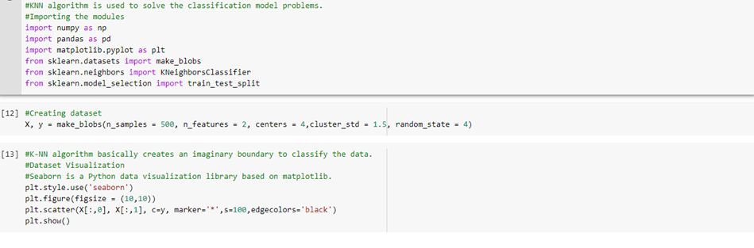

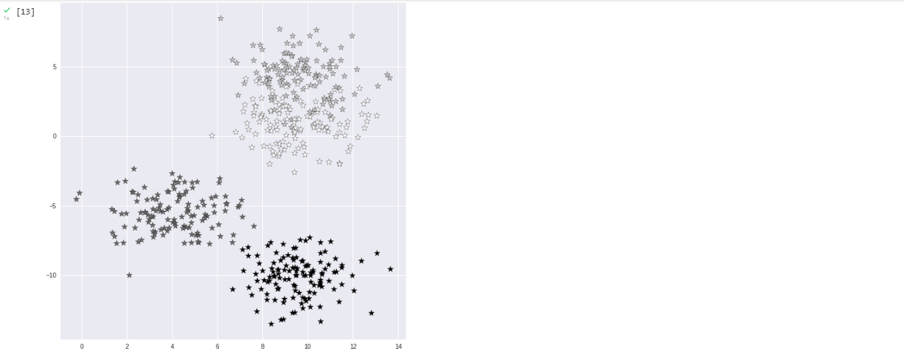

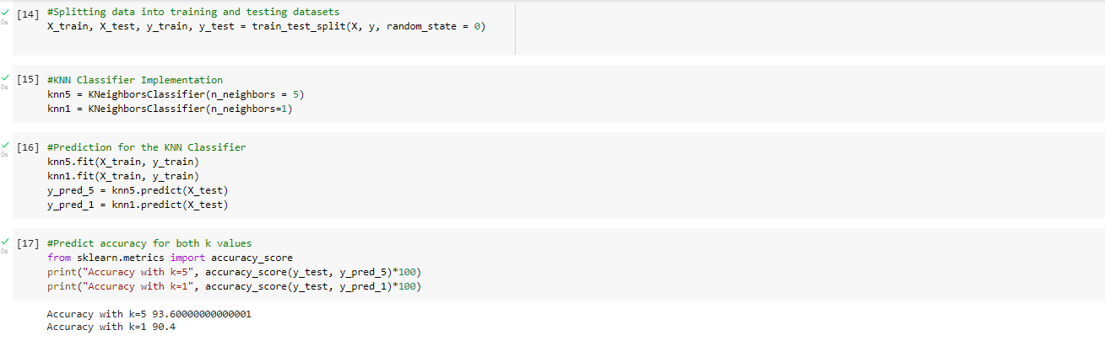

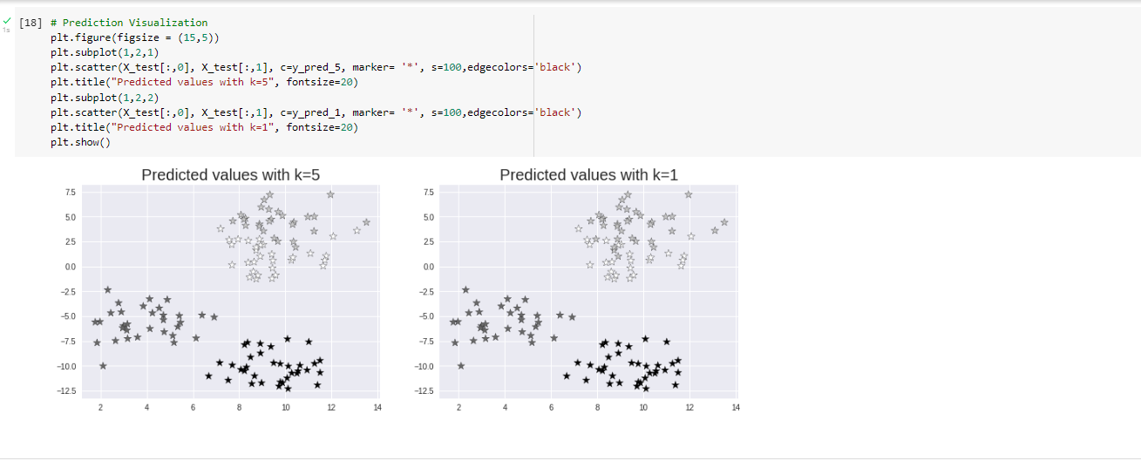

**Learning outcomes (What I have learnt):**

1. Learning about different library/packages of python.
2. Learning about the different methods, that are needed to analyze the given dataset.
3. Learning about different Machine Learning Functions.
4. We learn to split data into training and testing datasets.
5. Implementation of k-nearest neighbors (KNN) algorithm.